NORTH CAROLINA SYNODICAL WOMEN’S ORGANIZATION
www.ncwelca.com
THE BULLETIN
March-April 2024
~~~~~~~~~~~~~~~~~~~~~~~~~~~~~~~~~~~~~~~~~~~~~~~~~~
The Bulletin is the official publication of the NC Women of the ELCA, published bi-monthly. Articles and information relating to the Women of the ELCA are accepted for publication, following review by the Synodical Women’s Organization (SWO) President and the SWO Secretary, who serves as the Editor. You may submit articles to Anita Miller, anitamiller0919@gmail.com, or 150 New Sterling Road, Stony Point, NC 28678 .
~~~~~~~~~~~~~~~~~~~~~~~~~~~~~~~~~~~~~~~~~~~~~~~~~~
CONTENTS

Articles:
From the Desk of the President pg2
Prayers for LTSS pg3
From the Treasurer pg3
RMHC Poland pg 3,4
Election Time pg4
Stewardship Update pg5
Acts of Kindness Family pg6
Kaleidoscope Power of Prayer pg 7
Spring Gathering Dates/Locations pg8
Annual Gathering Info pg9,10
From Descipleship pg11
2024 Coastal Retreat Photos pg12-14

Attachments:
Annual Gathering Promo
Annual Gathering Registration forms
Annual Gathering In Kind Gifts
Nomination Forms Positions available:
Treasurer, 4 Board members

As a community of women created in the image of God, called to discipleship in Jesus Christ, and empowered by the Holy Spirit, we commit ourselves to grow in faith, affirm our gifts, support one another in our callings, engage in ministry and action, and promote healing and wholeness in the church, the society, and the world.
PURPOSE STATEMENT

OUR MISSION
Mobilizing women to act boldly on their faith in Jesus Christ.

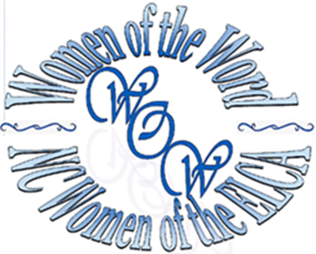
FROM THE DESK OF THE PRESIDENT:
Good day, Ladies! Happy March/April!
Even though this message seems shorter than my others, it is a deep dive for your thoughts. I wouldn’t be surprised if you aren’t still thinking about this for weeks to come. As women, we are massive multitaskers! We learn from an early age how to multitask without even knowing it. Along with all our different responsibilities, we also work hard for our families, churches, organizations, jobs, etc. But, do we work that hard for ourselves? For example: these past couple of months I have been working on getting
things squared away with Church Wide for the new year, working with/on the upcoming Spring Retreat, leading the Call Committee for Ascension, serving as Secretary on the council for Ascension, fulfilling my presidential duties for our Women, trying to perform at my J. O. B, and just trying to be a decent human! This has been………..one HUGE full plate! But, I felt
accountable and was determined to fulfill the responsibilities I was given. As in my example above, have you ever noticed that we, WOW Women, strong women, tend to overload our responsibilities? We do this to ourselves quite frequently. Do we not trust others to do it as we would like or needs to be done. Do we think that we are the only one who can handle the
work? Do we feel that if we don’t do it, no one will?
Do we have the anxiety of never really being good enough so we load on more and more
responsibilities trying to prove that we are?
Are we pushing so hard for outside
accomplishment because we don’t feel we are
worthy when we look inside ourselves? In today’s world, we carry with us every day many racing thoughts, dreams, worries, hopes, anxieties, responsibilities, and jobs. We all do. Our
shoulders should be as strong as Samson’s! But, honestly, deep down, why do we hardly ever stop to think “Is this too much?”? Or, “What will is the end game for doing all this?”. Better yet, “Does anyone notice how hard all this is? Can they see I’m struggling?”. And one that I know I am guilty of, “If I do just one more thing I will be worthy of their friendship, love, and/or acceptance.” Taking a moment to think about all this and how our responsibilities in the world have changed so much in just a few years, I
can’t help but remember Kimberly Rae’s, the Christian author presentation at one of our annual gatherings. We invited Mrs. Rae to be the Keynote Speaker at LR University in 2014.
She did a very eye-opening presentation on “The Veils We Wear”. I could never explain her presentation justly. It brought such joy, tears,
understanding, and realization to so many of us. From time to time I am known to use these lessons from her presentation. We are so rushed. So worried. So full of anxiety and doubt! I implore you to watch these links:
https://www.youtube.com/watch?v=NP2f2yA2CP0 ,
https://www.youtube.com/watch?v=e7DIR5Dw08k , and
https://www.youtube.com/watch?v=s_PJwMOH8lI .
Take the time to grab a fresh cup of coffee, a snack, and watch these videos. They are short,
but so full of truth! You WILL NOT be sorry!! Let Kimberly help you find the inner peace that you may seek. We’ve got to be proactive at squashing
our self-doubt and remember to give it to God.
If no one has told you today:
YOU ARE GOOD ENOUGH.
YOU HAVE SO MUCH TO OFFER OTHERS.
YOU ARE FEARFULLY AND WONDERFULLY MADE I LOVE YOU ALL!

Psalm 46 says: “God is our refuge and strength, a very present help in time of trouble. Therefore,
though the mountains shake in the heart of the sea…” (v. 1-2). Despite the desolation and
devastation of the natural disasters and political turmoil, God remains present, steady and strong.
God, our mighty fortress, does not fail us. God speaks to us through the storm: “Be still, and know
that I am God!” (v. 10a).
Respectfully submitted,
Lisa Philbeck
NC Women of the ELCA President
Lisa Philbeck
President, NC Women of the ELCA
OFFERING REMITTANCES SHOULD BE FORWARDED TO:
DEBRA WEINEL, SWO TREASURER
1612 Sherburg Court
Raleigh, NC 27606

CU Treasurers should continue to use Form A.

deweinel@gmail.com

(919)851-3093 Home (919)215-6624 Cell

A Prayer to Share
We pray for Lutheran Theological Southern Seminary in Columbia, SC. Education will continue at Lenoir Rhyne University in January 2025. We lift up the stakeholders, staff, administration, faculty and students in the coming months. Lord in your mercy, receive our prayers.
From Your Treasurer:

One of my jobs as your Treasurer is to send a note of thanks to all the congregational unit treasurers for your monetary gifts from last year. As you know, our year ends on January 31 so it is this time of year that I look back at the offerings you so generously gave to the NC Women of the ELCA.

It is so appropriate that I would finish my thank you notes today on Valentine's Day because I could feel the love you give to the women not only with offerings but with your prayers and support.

Please know that I appreciate all you do for the NC Women of the ELCA and it is a privilege to serve as your NC Treasurer.
--
Walk in Light,
Debra Weinel
Treasurer of the NC Women of the ELCA

When RMHC Poland started their “Say No to Cancer in Children” program in 2006, Basia had no idea how essential it would be ...until it saved the life of her daughter Dobrusia.
Basia, Dobrusia and their family live in a small mountain village in Poland. Unfortunately, families living outside big cities often lack the means to get their children tested proactively and preventative abdominal ultrasound examinations are not generally reimbursed by the national health care providers,
To close this gap, RMHC Poland uses their Ronald McDonald Care Mobile program to deliver preventive screenings and tests for cancer and other serious illnesses to families who may not have access otherwise. The Care Mobile in Poland is fitted with ultrasound technology and certified pediatric radiologists who can perform rapid cancer screening tests to deliver results within 30 minutes.
When the Care Mobile visited their village, Basia had Dobrusia examined and was stunned to learn Dobrusia had an early-stage cancer. With this valuable information and because the family could also stay at the Ronald McDonald House near the hospital, Dobrusia was able to begin treatment immediately - and they were always together and cared for, despite being hundreds of miles from their home.
After several series of treatments and stays at the House, Dobrusia is now cancer-free and Basia is a strong advocate for the “Say No to Cancer in Children” program sponsored by RMHC Poland.
“Please give my message to the world: time is the most important factor when it comes to health! That’s why preventive care is so important,” said Basia.
“Say No to Cancer in Children” is the longest-running program for RMHC Poland, delivering over 87,000 free pediatric cancer screenings since its inception. In addition to helping initiate treatment for sick children, these screenings have saved families in need over 4-million Euros in medical fees.
“Our most important impact has been saving children’s lives and health,” says Krzysztof Daniluk, RMCM Program Manager in Poland. “With this program and our two Houses and three Family Rooms, we are proud to serve children and families all along their healthcare journey.”
LADIES, IT PRIMARY ELECTION TIME, TIME FOR US TO BE HEARD,
REGARDLESS OUR OPINION.
Here are some facts and dates you need to know.
• Photo ID required. Can use drivers license or US Passport that’s unexpired or
expired for one year or less. Can also go to your local Board of Election and have a
voter ID card made prior to going to vote. All Veteran ID, even if expired, can be
used. Check NCSBE for more details
• Photo copy of ID required for absentee ballot.
• January 19: Absentee Ballots are available.
• February 15: Early voting begins.
• February 27: Last day to request absentee ballot.
• March 2: Early voting ends at 3 p.m.
• March 5: Primary Election Day
• March 5 @ 7:30: All absentee ballots must be at your local board of election by 7:30.
This is a change in state law. Up to this year, you had a 3 day grace period to get
ballot in.
Recommendation: Go to North Carolina State Board of Election to check new laws, to verify
your registration and to find sample ballots.
Former Professor Brandon of LRU told his government class: “If you don’t
vote you forfeit the right to complain.
MAIN POINT WELCA LADIES OF NORTH CAROLINA: VOTE, VOTE,
VOTE!!!!!
From Stewardship: Love you More in 2024
Ladies, greetings from your Stewardship Committee, we hope your new year to off to a good start. As we look ahead to the Women of the ELCA’s new year, which starts on February 1, we would like to share with you new information on the distribution of Regular Offerings.
We so appreciate everyone who gives to our regular offerings in your congregations and the lovely treasurers who take their time to send them to me, your NC Synod Women of the ELCA Treasurer.
As we look ahead to February 1, the Stewardship Committee has prayerfully considered how best to use your Regular Offerings. With the NC Board’s approval, 30% more of your Regular Offerings will stay in North Carolina. This will help us meet our commitments throughout this year as we support the NC Women in planning Committee Days, the Annual Gathering, NC Board Meetings, introduce a new website and prepare for future endeavors.
Sincerely, Debra Weinel, NC Treasurer
treasurerncwelca@gmail.com

A Place Between Home and Homeless:
Acts of Kindness Family
An interview with Denise Sharrow,
Manager of Brookwood Inn, Statesville, NC
How does a family find themselves living in a motel?

Before covid: Evictions, divorce, death, loss of a job, mismanagement of money.

During and since covid: Moving into a home or apartment has not been a viable option. Working poor families are now completely priced out of the housing market. The demand for income based housing or subsidized housing is at an all time high, the supply is not meeting the demand. Living in a motel is their only option. And the cost of weekly rent in a motel is rising. Working mothers and families cannot pay.

Acts of Kindness raises money for weekly rent, car repairs, medications, food, and other expenses. Outreach began with Bible studies, cookouts, holiday celebrations, the Good News Club, collecting donations of household goods, hygiene products, after school snacks, food and gas cards.

Being poor does not mean you do not know and love Christ. The guests are not lazy, they are not addicts, and they all work. Each one at one time or another in the not so distant past, had a home. Just like any other neighborhood, some attend church, Bible study and some do not, all of our children attend bible study on Wednesday nights at the Salvation Army.

There are 20 families and 30 children. Young couples, seniors and single men live here. They work or have an income, but have been priced out of the housing market. Each person here is doing the absolute best they can do to survive, each person works. We are in a housing crisis and things are not improving.

Brookwood Inn is a blessing. God has at every step intervened here for us. I have an owner who is Hindu, but allows me to talk about Christ and help others, an owner who allowed me to clean the place up, be picky about who we rent to, have Bible Study, Christmas dinners. This has been Gods plan from the beginning. We have learned to be humble, content in all circumstances and we know firsthand there by the grace of God go I.
***********************************************
Hello Conference Leaders and all the women of NC Women of the ELCA!
I’m writing this after attending the One Day Retreat “Kaleidoscope” which was centered around prayer. I was encouraged by how many of us attended the One Day Retreat at several locations across the state. I came away from the retreat feeling uplifted and refreshed, and two things were brought into focus for me in my role as Conference Coordinator.
First, I was reminded of the “Power of Prayer”. I have been struggling since the New Year and I had been taking prayer for granted. What a timely reminder that there is tangible power behind the mechanism of praying, especially when there are voices in unison focused on the same goal. Second, it’s very evident to me that women are more than willing to participate in local events with such a fantastic attendance at the One Day Retreat locations.
Now how does this relate to the Conference Leaders, the Spring Conference Gatherings and the upcoming elections? I truly believe that it’s events like the One Day Retreat and the Conference Gatherings that are going to rebuild our foundation and get more women fully engaged in NC WELCA. To date we have five Conferences with Spring Gatherings scheduled (Alexander/Iredell, Central/Salem, Sandhills, Smoky Mountain, Southwest) and two others that are tentative (Cabarrus/Stanly, Meck/Union). That means we still have at least seven of our Conferences that are still looking for a Host Church.
So my request of you is simple. Please pray for NC Women of the ELCA. Please pray in unison for success and progress as NC WELCA continues to rebuild. In your prayers, please ask how you and your home church can be part of our rebuilding. Then remember to allow time to listen while praying. Listen and give God a chance to respond. Maybe your church can offer to host a Conference Gathering. Maybe God will nudge you tl, put aside your hesitation and volunteer to be elected as Presider at your Spring Gathering. Maybe you haven’t attended a Conference Gathering in awhile and your leap of faith is participating in your Spring Gathering. The possibilities are endless when you have the Power of Prayer surrounding you!
Jane VonCannon presented the One Day Retreat at Grace Lutheran in Salisbury where I attended. I have known Jane for years as a former Presider for Rowan Conference, and she was an outstanding Conference Leader! But in all the years I’ve known her, Jane had never presented an hour-long program, never mind facilitate an entire day-long retreat. Jane shared with me before the retreat began that when she was asked by the Discipleship Committee if she would facilitate “Kaleidoscope”, her initial instinct was to decline. Instead she said she would pray about it, and that’s exactly what she did. Well, God woke her up at 3:00 in the morning to tell her that she was going to say Yes, and that He would be by her side the entire time. And what an awesome job Jane did as she led us throughout the day, engaging us all with her knowledge, humor and passion.
That night, after hearing Jane’s story, I stopped talking so much when praying at the end of my day (as I have a tendency to do), and I took time to listen. I’m grateful I did. God gently reminded me of a Bible Study I wrote years ago titled “God’s Math”. Now I’m a numbers person and in my world 5 + 2 = 7. But God’s math goes something like this: 5 + 2 = 5,000. You know what I’m referring to – the story of Loaves and Fishes. This is just one of countless examples of God’s Math throughout scripture. So I have renewed hope that you, too, will be listening to discern how you can join NC WELCA in our journey to reclaim our future.
God’s Peace,
Lorri Monterose, Conference Coordinator
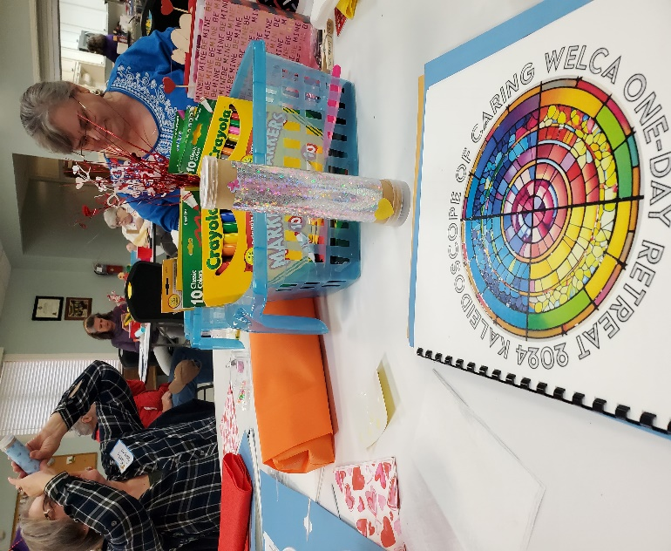

Spring Gathering Dates and Locations:
April 13: St. Paul’s Statesville
St. John’s Concord
Mt. Moriah, China Grove

April 20: Shiloh, Lewisville
St. James, Fayetteville
Daniels, Lincolnton
Living Waters, Cherokee

May 4, Living Savior, Charlotte
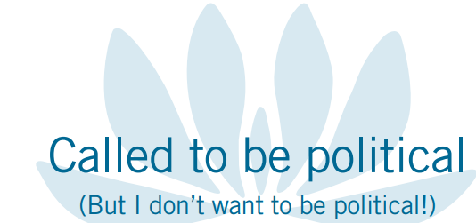

Annual Gathering of the
NC Women of the ELCA
June 21-23, 2024
Lenior Rhyne University
IMPORTANT INFORMATION
- Lodging in Fritz/Conrad
- Meeting in Belk Centrum
- Sunday Worship in Grace Chapel
- Golf carts available as needed
IMPORTANT PEOPLE THIS WEEKEND
Chaplin—Rev. Denise Henry
Keynote —Dr. Jacqueline Bussie
Entertainment—Paul & Sophia Chandley
WELCA Churchwide Representative
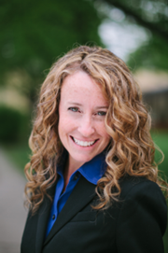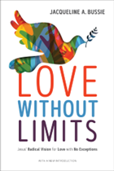
"Dr. Jacqueline Bussie is an award-winning author, professor, public theologian, and student of life in all its messy beauty, as well as a much sought after speaker and workshop facilitator. Her first book, The Laughter of the Oppressed won the national Trinity Prize. Her 2ndbook, Outlaw Christian: Finding Authentic Faith by Breaking the Rules won the 2017 Gold Medal Illumination Award for Christian Living and received a coveted starred review from Publishers Weekly. Her 3rd and latest book, Love Without Limits: Jesus’ Radical Vision for a Love with No Exceptions won the Reader’s Favorite Bronze Medal International Book Award for Christian Living, the 2020 IAN Outstanding Religion Book of the Year Award, and 3rdPlace IAN Non-Fiction Book of the Year Award. Also, Publisher’s Weekly named Love Without Limits “a must-read for all Christians interested in inclusivity for their communities.”
An active servant-leader in the Evangelical Lutheran Church in America, Jacqueline spent the last twenty years teaching religion to undergraduates at ELCA colleges and serving as the founding Director of the Forum on Faith and Life at Concordia College. Jacqueline's favorite things to do are walk on the beach, read good books, ride in the front car of roller coasters, spend time with friends, and travel to any place she's never been before.”
*****************************************
PAUL & SOPHIA
DUO PIANISTS
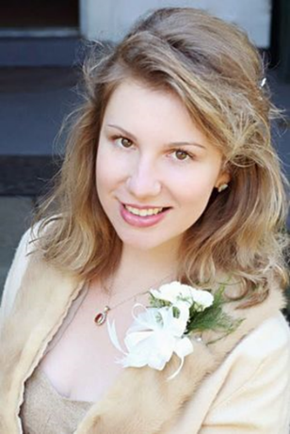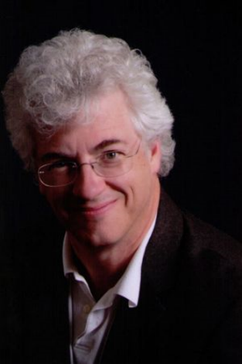

“Four Hands, Two Pianos, One Heart”
Paul & Sophia – Short Bio
Paul Chandley is from the mountains of east Tennessee and western North Carolina. A child prodigy, he could read music notes before he could read words. Sophia Pavlenko, born in Siberia and raised in Kiev, Ukraine, was also a child prodigy who wrote her first composition at age 5. Consummate solo performers, they met when the Kiev Symphony and Chorus lost one of its U.S. venues and substituted a performance in the small North Carolina town where Paul was director of the Trinity Music Academy. It was love at first sight. Sophia spoke little English, Paul spoke no Russian, but according to Sophia, “When we met, we connected on a musical/emotional level.” “Music crosses all cultural boundaries,” explains Paul, “and speaks directly to the heart. Playing with Sophia the first time was the most fun I've ever had.” After a year's international courtship, they were married in that small North Carolina town and their future as a piano duo was sealed. Paul and Sophia have been delighting audiences for the past 18 years with their own arrangements from Classical Favorites to Ragtime, along with Sophia's dynamic original compositions. When two pianos are not available, they load theirs (one, Paul's wedding gift to Sophia, belonged to Rachmaninoff) into a truck, and haul them to the venue. The sounds that floats from their two pianos have been called “virtuosic, beautiful, very approachable, very listenable.” It is evident that Paul and Sophia love the music that they play. Their enthusiasm radiates across the footlights to the audience who by the end of the concert, has leaped to its feet. The couple launched The Paul and Sophia Music Foundation in February 2017, to support, educate and nurture a new generation of musicians.
***********************************************
LEARN ABOUT
Penny Ministry:
Sleep in Heavenly Peace
Spring Gathering Offering: Mothers and Their Children
Lutheran Services Carolinas
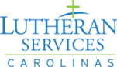

What’s Happening in the WELCA
Lutheran Disaster Response
***********************************************
Lutheran Women have a long history of Bible Study, Discipleship, and a desire to deepen their spiritual life and learn about issues to help us grow in faith and engage in ministry and action. Most importantly, we want others to know Christ as we know him – a kind, compassionate, merciful and loving savior. As Women of the Word, we want to share the message of Christ with others.
Many of our congregational units enjoy Bible studies but many of our members feel they are not capable of presenting a Bible study or even a program. Studies can be found in various publications from many different denominations. Our own Gather magazine offers Bible studies and devotions each month. Personally, I use daily devotionals that I pick up at several different churches. Some of these have wonderful personal stories that relate to the scripture for the day and many of which I can relate to myself. So, if you want to write your own Bible study, check these out. The Women of the ELCA website (WELCA.org) has many available resources to use for presenting programs and also gives instructions on how to use and present the material. So, if you are the “anxious” type and do not like to speak in front of others, the instructions lay it all out for you, even down to the time which allows you to determine how many sessions to plan for.
Under the Resources section on the webpage is a study worth checking into - Gifts for You (Opening your spiritual gifts). It includes 2 separate Bible studies: 1-From the Beginning and
2-The Plan (God’s Word about Gifts). At the end of The Plan, is an Appendix describing Spiritual gifts, giving characteristics, cautions and biblical references. The work of the Holy Spirit is an awesome mystery for each of us. Because the way these spiritual gifts are given to us and manifested in us, it is better to provide a description rather than a narrow, one-size-fits-all definition. These descriptions will give you a picture in words that will lead you to an image of your spiritual gifts. Where do you fit into this beautiful tapestry of the Holy Spirit at work in you?
Marguerite Taylor
Discipleship Committee

2024 Coastal Retreat !!
